**Experiment - 3**

**Student Name: Vivek Kumar UID: 21BCS8129**

**Branch: BE-CSE(LEET) Section/Group: WM-20BCS-616/A**

**Semester: 5th Date of Performance: 16/08/2022**

**Subject Name: Project Based Learning in Java Lab Subject Code: 20CSP-321**

**1. Aim/Overview of the practical:**

Create an application to calculate interest for FDs, RDs based on certain conditions using inheritance.

**2. Task to be done/ Which logistics used:**

Write a program to create an application to make an Account holders list and calculate interest for FDs, RDs based on certain conditions using inheritance.

**3. Software Requirements (For programming-based labs):**

* JDK-8 or any
* Eclipse-IDE for Java

**4. Steps for experiment/practical/Code:**

package Unit1;

import java.util.Scanner;

class InvalidAgeException extends Exception{}

class InvalidAmountException extends Exception{}

class InvalidDaysException extends Exception{}

class InvalidMonthsException extends Exception{}

abstract class Account {

double interestRate;

double amount;

abstract double calculateInterest(double amount)throws InvalidMonthsException,InvalidAgeException,InvalidAmountException ,InvalidDaysException;

}

class FDaccount extends Account {

double FDinterestRate;

double FDAmount;

int noOfDays;

int ageOfACHolder;

double General, SCitizen;

Scanner FDScanner = new Scanner(System.in);

double calculateInterest(double amount) throws InvalidAgeException,InvalidAmountException,InvalidDaysException {

this.FDAmount = amount;

System.out.println("Enter FD days");

noOfDays = FDScanner.nextInt();

System.out.println("Enter FD age holder ");

ageOfACHolder = FDScanner.nextInt();

if (amount < 0) {

throw new InvalidAmountException();

}

if(noOfDays<0){

throw new InvalidDaysException();

}

if(ageOfACHolder<0){

throw new InvalidAgeException();

}

if (amount < 10000000) {

if (noOfDays >= 7 && noOfDays <= 14) {

General = 0.0450;

SCitizen = 0.0500; }

else if (noOfDays >= 15 && noOfDays <= 29) {

General = 0.0470;

SCitizen = 0.0525;

} else if (noOfDays >= 30 && noOfDays <= 45) {

General = 0.0550;

SCitizen = 0.0600;

} else if (noOfDays >= 45 && noOfDays <= 60) {

General = 0.0700;

SCitizen = 0.0750;

} else if (noOfDays >= 61 && noOfDays <= 184) {

General = 0.0750;

SCitizen = 0.0800;

} else if (noOfDays >= 185 && noOfDays <= 365) {

General = 0.0800;

SCitizen = 0.0850;

}

FDinterestRate = (ageOfACHolder < 50) ? General : SCitizen;

} else {

if (noOfDays >= 7 && noOfDays <= 14) {

interestRate = 0.065;

} else if (noOfDays >= 15 && noOfDays <= 29) {

interestRate = 0.0675;

} else if (noOfDays >= 30 && noOfDays <= 45) {

interestRate = 0.00675;

} else if (noOfDays >= 45 && noOfDays <= 60) {

interestRate = 0.080;

} else if (noOfDays >= 61 && noOfDays <= 184) {

interestRate = 0.0850;

} else if (noOfDays >= 185 && noOfDays <= 365) {

interestRate = 0.10;

}

}

return FDAmount * FDinterestRate;

}

}

class RDaccount extends Account {

double RDInterestRate;

double RDamount;

int noOfMonths;

double monthlyAmount;

double General, SCitizen;

Scanner RDScanner = new Scanner(System.in);

double calculateInterest(double Ramount) throws InvalidMonthsException,InvalidAmountException ,InvalidAgeException {

this.RDamount = Ramount;

System.out.println("Enter RD months");

noOfMonths = RDScanner.nextInt();

System.out.println("Enter RD holder age");

int age = RDScanner.nextInt();

if (RDamount < 0) {

throw new InvalidAmountException();

}

if(noOfMonths<0){

throw new InvalidMonthsException();

}

if(age<0){

throw new InvalidAgeException();

}

if (noOfMonths >= 0 && noOfMonths <= 6) {

General = .0750;

SCitizen = 0.080;

} else if (noOfMonths >= 7 && noOfMonths <= 9) {

General = .0775;

SCitizen = 0.0825;

} else if (noOfMonths >= 10 && noOfMonths <= 12) {

General = .0800;

SCitizen = 0.0850;

} else if (noOfMonths >= 13 && noOfMonths <= 15) {

General = .0825;

SCitizen = 0.0875;

} else if (noOfMonths >= 16 && noOfMonths <= 18) {

General = .0850;

SCitizen = 0.0900;

} else if (noOfMonths >= 22) {

General = .0875;

SCitizen = 0.0925;

}

RDInterestRate = (age < 50) ? General : SCitizen;

return RDamount * RDInterestRate;

}

}

class SBaccount extends Account {

double SBamount , SbInterestRate, interest;

Scanner SBScanner = new Scanner(System.in);

double calculateInterest(double amount) throws InvalidAmountException{

this.SBamount = amount;

if(SBamount < 0 ){

throw new InvalidAmountException();

}

System.out.println("Select account type \n1. NRI \n2. Normal ");

int accountChoice = SBScanner.nextInt();

switch (accountChoice) {

case 1:

SbInterestRate = .06;

break;

case 2:

SbInterestRate = .04;

break;

default:

System.out.println("Please choose right account again");

}

return amount * SbInterestRate;

}

}

public class InterestCalculator {

public static void main(String[] args) {

boolean val=true;

Scanner sc = new Scanner(System.in);

while(val) {

System.out.println("SELECT THE OPTIONS " + "\n1." + " Interest Calculator-SB" + " \n2." + " Interest Calculator-FD" + "\n3." + " InterestCalculator-RD" + "\n4 " + " Exit");

int choice = sc.nextInt();

switch (choice) {

case 1:

SBaccount sb = new SBaccount();

try {

System.out.println("Enter the Average SB amount ");

double amount = sc.nextDouble();

System.out.println("Interest gained is : Rs " + sb.calculateInterest(amount));

} catch (InvalidAmountException e) {

System.out.println("Exception : Invalid amount");

}

break;

case 2:

try {

FDaccount fd = new FDaccount();

System.out.println("Enter the FD Amount");

double fAmount = sc.nextDouble();

System.out.println("Interest gained is: Rs " + fd.calculateInterest(fAmount));

} catch (InvalidAgeException e) {

System.out.println("Invalid Age Entered");

} catch (InvalidAmountException e) {

System.out.println("Invalid Amount Entered");

} catch (InvalidDaysException e) {

System.out.println("Invalid Days Entered");

}

break;

case 3:

try {

RDaccount rd = new RDaccount();

System.out.println("Enter the RD amount");

double Ramount = sc.nextDouble();

System.out.println("Interest gained is: Rs " + rd.calculateInterest(Ramount));

}

catch (InvalidAgeException e) {

System.out.println("Invalid Age Entered");

} catch (InvalidAmountException e) {

System.out.println("Invalid Amount Entered");

} catch (InvalidMonthsException e) {

System.out.println("Invalid Days Entered");

}

break;

case 4:

val=false;

System.out.println("DO YOU WANT TO CALCULATE AGAIN ????" + " "

+ "RUN AGAIN THE PROGRAM");

default:

System.out.println("Wrong choice");

}

}

sc.close();

}

}

**5. Observations/Discussions/ Complexity Analysis:**

Based on the questions here I have created the abstract class named as Account, and then FDaccount, RDaccount and SBaccount class which extends the Account class and then Final class I have created the IntrestCalculator which contains the main method of java program that is based on the question.

**6. Result/Output/Writing Summary:**

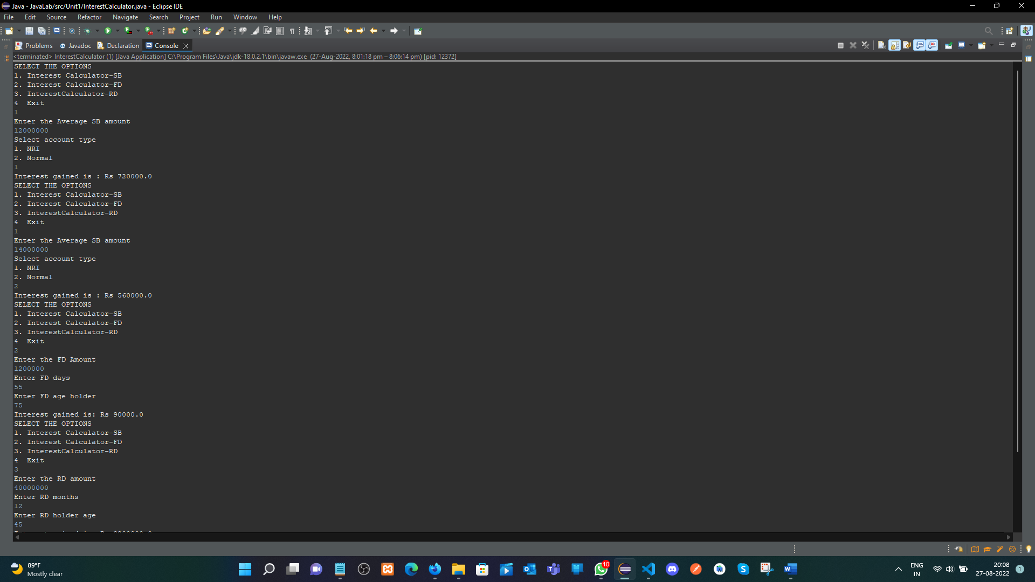

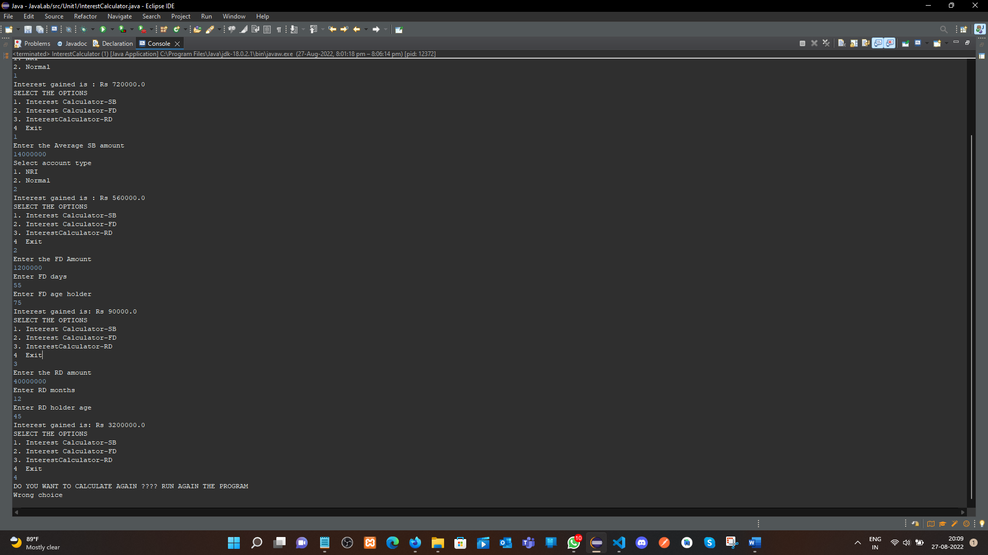

**Learning outcomes (What I have learnt):**

**1.** Here we have learnt the Concept of Inheritance with the Abstract class

**2.** And finding the Interest, SB, RD & FD based on the Amount, Citizenship and Age group.

**Evaluation Grid (To be created as per the SOP and Assessment guidelines by the faculty):**

|  |  |  |  |
| --- | --- | --- | --- |
| Sr. No. | Parameters | Marks Obtained | Maximum Marks |
| 1. |  |  |  |
| 2. |  |  |  |
| 3. |  |  |  |
|  |  |  |  |